1. **Barcode Creation**

Barcode creation is one of the main functionality to be fulfilled via the 2DBC System whereas it functions under two main levels within the system as,

* 1. Create barcodes by guest users who access the system without logged in.
  2. Create barcodes by users who logged in to the system.
  3. **Use Cases**

Once user accesses the system by typing the valid URL it displays the system home page which allow any user (guest user) to create barcodes. By giving the relevant inputs guest user will be able to generate barcodes under different types but with the limited features.

By proper navigating through the user login valid users can logged in to system for creating barcodes with more features. Also logged users are able create bulk of barcodes at once by uploading a valid csv file. Every created barcodes by logged users are listed under a campaign.

* + 1. Use Case: Create barcodes by guest users who access the system without logged in.



Figure 3.1 Guest user create barcodes

1. User enters the URL and system home page displays.
2. Give inputs and create barcode.
3. Validate the inputs and generate barcode accordingly.
   * 1. Use Case: Create barcodes by users who logged in to the system.

Create barcodes by logged in users are mainly differentiate by two user types (Reference SRS ……..) of the system.

1. Barcodes/Bulk Barcodes created by CSA/CA



Figure 3.2 CSA/CA create barcodes

1. CSA/CA logged in to the system.
2. Navigate for the ‘Create Barcode’
3. Select LOB. According to the LOB, select Campaign and give other inputs for the barcode creation.
4. If user wants they can create bulk of barcodes.
5. Validate Inputs and generate barcodes.
6. Barcodes/Bulk Barcodes created by CU



**Figure 3.3 CU create barcodes**

1. CSA/CA logged in to the system.
2. Navigate for the ‘Create Barcode’
3. Select Campaign and give other inputs for the barcode creation.
4. If user wants they can create bulk of barcodes.
5. Validate Inputs and generate barcodes.
   1. **Non Functional Requirements**

Codes can be either QR or Data matrix which triggers Go To Website, Message, Contact Details, Send SMS, Initiate Call.

1. Support short URLs and/or Direct URLs in the case of go to web site barcodes
2. Support multiple error correction option for QR codes
3. Support multiple image formats
4. Support only for Dialog number for Contact Details, Send SMS, Initiate Call
5. Support short numbers also for Send SMS.
6. Ability to create codes (in bulk) for campaigns using CSV file upload

When creating barcodes these are the inputs:

|  |  |  |  |
| --- | --- | --- | --- |
|  | **Guest User** | **CSA/ CA** | **CU** |
| **LOB** | NA | Required | NA |
| **Campaign** | NA | Required | Required |
| **Barcode Action** | Go To Website, Message, Contact Details, Send SMS, Initiate Call | Go To Website, Message, Contact Details, Send SMS, Initiate Call | Go To Website, Message, Contact Details, Send SMS, Initiate Call |
| **Barcode Type** | Either QR / DM | Either QR / DM | Either QR / DM |
| **Barcode size** | Small/ Medium/ Large | 4x4, 8x8, 12x12, 16x16 | 4x4, 8x8, 12x12, 16x16 |
| **Error correction** | Low/ Medium/ Quality/ High | Low/ Medium/ Quality/ High | Low/ Medium/ Quality/ High |
| **Image Type** | NA | JPG/ GIF/ PNG/ EPS | JPG/ GIF/ PNG/ EPS |
| **Code Name** | NA | Required | Required |
| **Title** | Optional | Optional | Optional |

**Table 3.1 Creating Barcodes - inputs**

Barcode Action is again differentiate as,

|  |  |
| --- | --- |
| **Barcode Action** | **Attributes** |
| Go To Website | Real URL , Short code |
| Message | Text message |
| Contact Details | Name, Telephone No, Email |
| Send SMS | Telephone No, Message |
| Initiate Call | Telephone No |

**Table 3.2 Definition of Barcode Action**

For Bulk barcode creation csv file should be in the flowing format.

|  |  |
| --- | --- |
| **Column 1 :** | File name of the created barcode. Make this a unique name to avoid getting over-written |
| **Column 2 :** | Barcode Action, Should be one of;  WEB,MSG,CONTACT,SMS,CALL |
| **Column 3 :** | Content related to the selected action; If action is CONTACT, this should contain the following Information in this format <NAME: Jane Doe><PHONE:XXXXXXXXX><MAIL:jane@doe.com> |
| **Column 4 :** | Size should be one of the 4,8,12 or 16 (ie. in centimeters). Providing one value is sufficient as the barcode will be a rectangle |

**Table 3.3 CSV File format for bulk barcode creation**

* 1. **User Interfaces**
     1. Guest User Create Barcodes

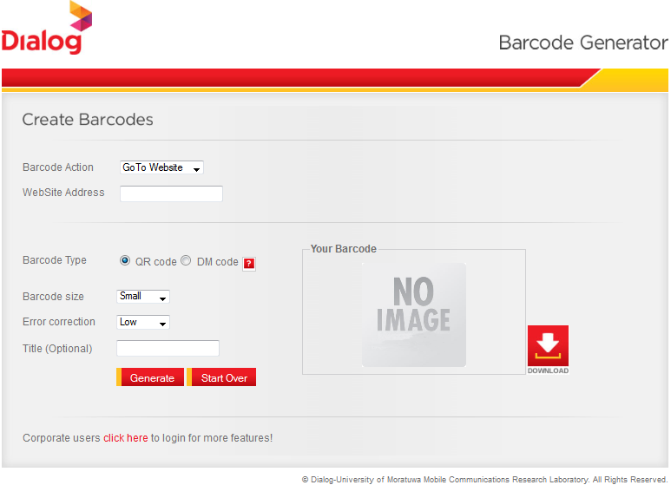

**Figure 3.4 User Interface of guest user create barcodes**

* + 1. CSA/CA Creates Barcodes

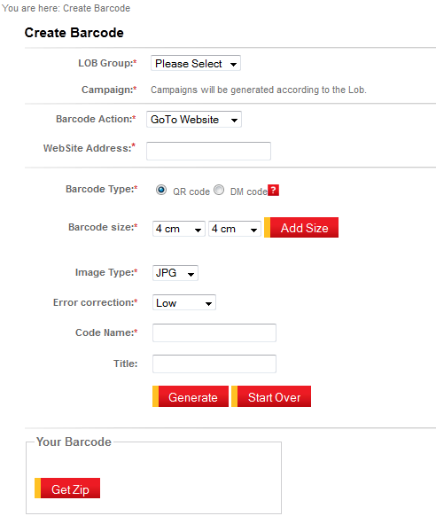

**Figure 3.5 User Interface of CSA/CA create barcodes**

* + 1. CSA/CA Create Bulk Barcodes

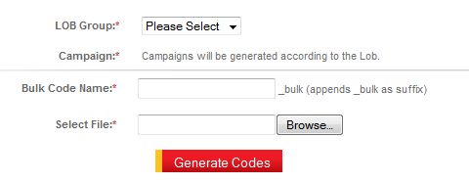

**Figure 3.6 User Interface of CSA/CA create bulk barcodes**

* + 1. CU Create Barcodes

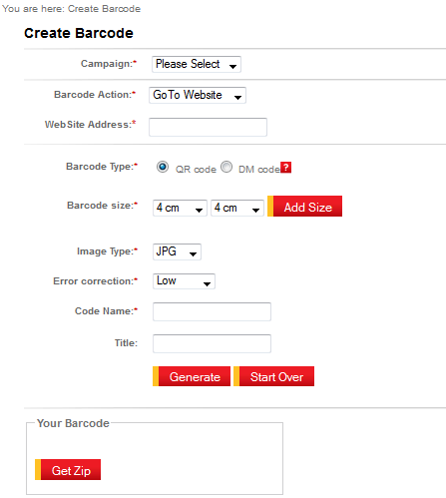

**Figure 3.7 User Interface of CU create barcodes**

* + 1. CU Create Bulk Barcodes

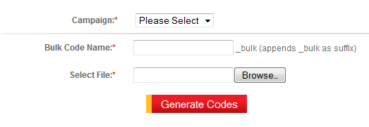

**Figure 3.8 User Interface of CU create bulk barcodes**